**Deep Weed Detection**

**Aim –** The main aim of this study is to build an image classifier capable of detecting the weed species when weed plant is provided as an input.

**Need of the study –**

* Early detection and monitoring - Early detection of weeds is crucial for effective management. By deploying deep weed detectors in the field, farmers can monitor weed populations in real-time and identify emerging weed infestations before they become widespread. This proactive approach enables timely intervention and helps prevent crop yield losses.
* Lowering production costs - Traditional weed management methods, such as manual labor or blanket herbicide application, can be costly and inefficient. By leveraging image-based detection, farmers can adopt precision weed management techniques, reducing the need for excessive herbicide use or labor-intensive weed control measures and lowering production costs.

**Dataset –**

The Deep Weeds dataset consists of 17,509 images capturing 8 different weed species native to Australia in situ with neighboring flora. The selected weed species are local to pastoral grasslands across the state of Queensland. The images were collected from weed infestations at the following sites across Queensland:

* Black River
* Charters Towers
* Cluden
* Douglas
* Hervey Range
* Kelso
* McKinlay
* Paluma.

Dataset size – 494 MB.

Data source – [*https://www.kaggle.com/datasets/imsparsh/deepweeds*](https://www.kaggle.com/datasets/imsparsh/deepweeds)

Steps to access the dataset:

1. Click the above link to go the source location.
2. Click the download to download the file to local.

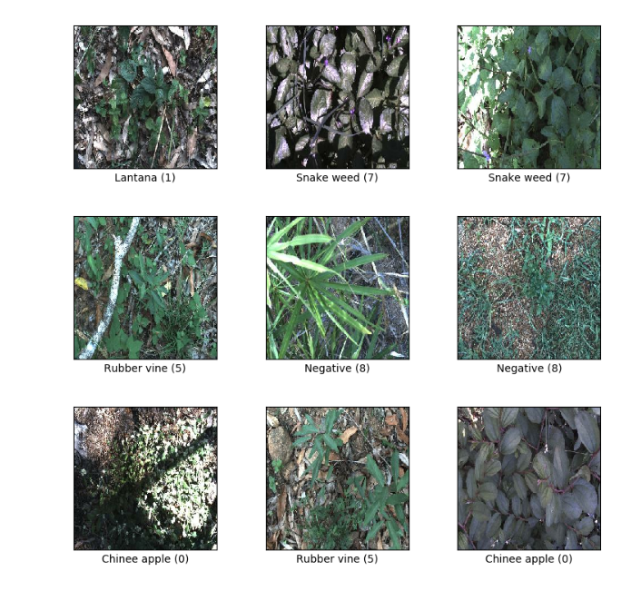

*Fig – Sample images from the dataset.*

**Applications –**

1. Deep weeds: A multi class weed species Image dataset for deep learning.

This paper provides a baseline for classification performance on the dataset using benchmark learning models Inception-V3 and ResNet-50. These models achieved an average classification accuracy of 95.1% and 95.7% respectively.

Reference - [*https://arxiv.org/abs/1810.05726*](https://arxiv.org/abs/1810.05726)

1. Weed recognition using deep learning techniques on class-imbalanced imagery.

In this paper five state-of-the-art deep neural networks VGG16, ResNet50, InceptionV3, InceptionV3-ResNetV2 and MobileNetV2 have been investigated. The results show that the VGG16 performed better than others on small scale datasets while ResNet50 performed better than others on large scale datasets.

Reference - *https://www.publish.csiro.au/cp/pdf/CP21626*